Independent Mental Health Advocacy

What is Advocacy?

Advocacy is helping people say what they want.

An advocate will work together with you.

Advocacy makes sure that you have a voice and a say in important decisions about your life and care.

About York Advocacy Hub
Free: You do not have to pay for our service.

Confidential: This means we don’t share information with other people or services unless there is a risk to yourself or someone else.

Independent: This means we are a separate organisation and advocates don’t work for social care and health services.

On your side: We are here to get your point across and we work for you, and no-one else.

Independent Mental Health Advocacy (IMHA)

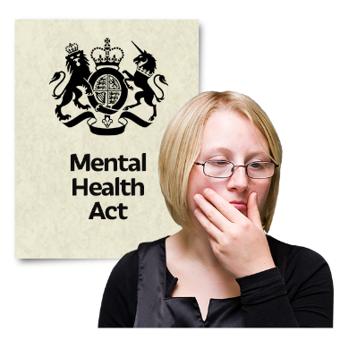
There is a law called the Mental Health Act

This law says when you can be sent to a mental health hospital or kept in hospital, even when you do not want to be there.

One of the rights in the Act is to have an Independent Mental Health Advocate (IMHA).

This is someone who helps you to speak up for what you want around your care and treatment in hospital.

What an independent mental health advocate will do
Your advocate will work with you to help you:
Understand your rights.
Understand what medical treatments you might be given
Listen to your views and feelings
We will support you to speak up for what you want, or speak up for you if needed.
They will go to meetings and tell health and social care staff what you would want to happen

An Independent Mental Health Advocate (IMHA) can also:
Your advocate can help you apply for a mental health tribunal or other meetings
They can go to the tribunal or other meetings with you
They can help you understand the decisions made at these meetings

Your advocate will help you raise issues such as hospital leave and getting the right support after you leave hospital.

What an independent mental health advocate won’t do

The advocate won’t make decisions for you

The advocate won’t tell you what to do

Contacting us

If you would like to see an advocate you can call us on 01904 414357 or email office@yorkadvocacy.org.uk

Name of the advocate who visited you: ________________________

Date they came to see you: ___________________________________

Advocacy Agreement

Issue | Goal / Outcome | Next Steps | Done by – who | Done by - timeframe
When you have read through this information please sign below to show you understand the information.

Your Name: ______________________________________ Date: ______________________________________
Advocate’s Name: _________________________________ Date: ______________________________________

