6th May 2021

Dear Applicant

Independent Advocate (Maternity Cover)

Thank you for your interest in the above position.

Please read the job description and person specification carefully and refer to the ‘person specification’ section to tell us clearly about how your experience matches with each section of the person specification.

You can download an application from our website www.yorkmind.org.uk/jobs or if you need support to download an application or would like an application form to be posted to you then please ring on 01904 414357. Guidance to help you to complete your application can also be found on our website.

Please do not send in your CV or other documentation as this will not be used in the shortlisting process.

Please return your completed application by post to the address above or email to vacancies@yorkmind.org.uk. We will be closing this vacancy at 9am Monday 11th January.

(Please note we will be shortlisting and interviewing shortlisted applicants as applications come in so reserve the right to close this vacancy and appoint someone prior to the closing date).

Interview date: To be discussed with applicant if shortlisted

Thank you for your interest in applying for work with York Mind. We look forward to hearing from you.

Yours sincerely

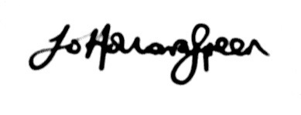
Jo Holloway-Green
Head of Client Services
York Mind

