York Advocacy Hub Information Sheet (Care Act)

What is Care Act Advocacy?

A Care Act advocate helps you have your say with your social worker.
Advocacy can help when -

You don’t know what your options are

You don’t agree with decisions that are being made about you

You can’t get the help you need

Free: You do not have to pay for our service.

Confidential: We don’t share information with other people if you don’t want us to – unless we think someone is at risk of harm

Independent: We are not part of the council or the NHS etc. This means we are a separate organisation and advocates don’t work for social care and health services.

We Can:
- Help you find out what your social worker is doing

- Help you have your say about your care needs

- Go to meetings and appointments with you

- Speak out on your behalf

We won’t:
- Give advice, opinions or tell you what to do

- Give you counselling or mental health support

- Keep working with you forever

Keeping records

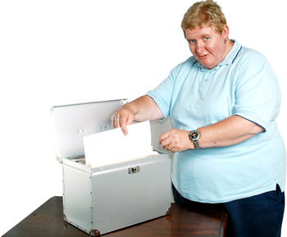
We keep records because they help us to remember things you have told us and so we can check we are doing a good job.

There are rules to make sure your records are private and safe.

If you want to see them please let us know.

What do we expect from you?

If you cannot attend a meeting please let us know by calling us on 01904 414357.

If you miss an appointment and we cannot contact you we will write to you. If we do not hear from you we will close your case.

Please do not attend advocacy meeting after drinking or taking drugs.

Physical or verbal aggression towards staff, other clients or property will not be accepted.

If you are not happy with how we work with you please tell the advocacy manager.

Advocacy Agreement

Issue | Goal / Outcome | Next Steps | Done by – who | Done by - timeframe
When you have read through this information please sign below to show you understand the information.

Your Name: ______________________________________ Date: ______________________________________
Advocate’s Name: _________________________________ Date: ______________________________________

